Operating System Lab 3

Dipesh Singh – 190905520

Question 1 : Write a C program to block a parent process until the child completes using a wait system call.

Source Code :

#include <unistd.h>
#include <sys/types.h>
#include <sys/wait.h>
#include <stdio.h>
#include <string.h>
#include <stdlib.h>

int main(){
pid_t pid;
int status;
pid = fork();
switch(pid){
case -1:
printf("Error occured, exiting ...\n");
exit(-1);
case 0 :
printf("Executing child process\nExiting child ...\n");
exit(0);
default :
wait(&status);
printf("Executing parent process\nChild status returned : %d\nExiting parent ...\n", status);
}
return 0;
}

Output :

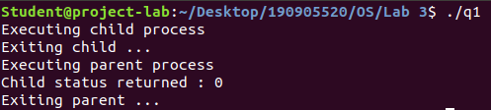
Question 2 : Write a C program to load the binary executable of the previous program in a child process using the exec system call.

Source Code :

#include <unistd.h>
#include <sys/types.h>
#include <sys/wait.h>
#include <stdio.h>
#include <string.h>
#include <stdlib.h>

int main(){
pid_t pid;
int status;
pid = fork();
switch(pid){
case -1:
printf("Error occured, exiting ...\n");
exit(-1);
case 0 :
printf("Executing child process of main program\n");
printf("_____\n");
execlp("./q1", "q1", NULL);
exit(0);
default :
wait(&status);
printf("_____\nExecuting parent process of main program\nChild status returned : %d\nExiting parent of main program ...\n", status);
}
return 0;
}

Output :

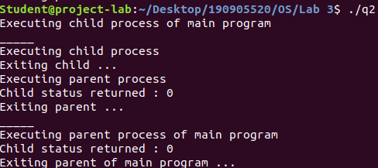
Question 3 : Write a C program to create a child process. Display the process Ids of the process, parent and child(if any) in both the parent and child processes.

Source Code :

#include <unistd.h>
#include <sys/types.h>
#include <sys/wait.h>
#include <stdio.h>
#include <string.h>
#include <stdlib.h>

int main(){
pid_t pid;
int status;
pid = fork();
switch(pid){
case -1:
printf("Error occured, exiting ...\n");
exit(-1);
case 0 :
printf("Executing child process\nProcess ID : %d\nParent Process ID : %d\nChild Process ID : %d\nExiting child ...\n", getpid(), getppid(), pid);
exit(0);
default :
wait(&status);
printf("Executing parent process\nChild status returned : %d\nProcess ID : %d\nParent Process ID : %d\nChild Process ID : %d\nExiting parent ...\n", status, getpid(), getppid(), pid);
}
return 0;
}

Output :

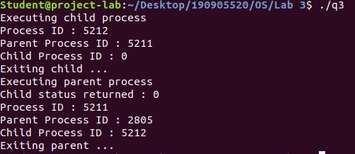
Question 4 : Create a zombie (defunct) child process ( a child with exit() call, but no corresponding wait() in the sleeping parent) and allow the init process to adopt it (after parent terminates). Run the process as a background process and run the “ps” command.

Source Code :

#include <unistd.h>
#include <sys/types.h>
#include <sys/wait.h>
#include <stdio.h>
#include <string.h>
#include <stdlib.h>

int main(){
pid_t pid;
int status;
pid = fork();
switch(pid){
case -1:
printf("Error occured, exiting ...\n");
exit(-1);
case 0 :
printf("Executing child process\nExiting child ...\n");
exit(0);
default :
sleep(5);
printf("Executing parent process\nChild status returned : %d\nExiting parent ...\n", status);
}
return 0;
}

Output :
